**King George’s Gate**

# Construction notice

Dear neighbour,

We are writing to update you on the plans for the site known as King George’s Gate. The site has been acquired by The Guinness Partnership, one of the largest providers of affordable housing and care in England. The Guinness Partnership was founded in 1890 to improve people’s lives and create possibilities for them. We continue to fulfil that purpose and their social purpose by providing great homes and services, including care services to over 140,000 customers across the country.

Permission was granted for a hybrid planning application in 2019, which means that construction will take place over two phases. The first phase, includes detailed permission to build 211 new homes, and infrastructure improvements. The

Guinness Partnership are also pleased to announce that 100 percent of homes built during phase 1 construction, will be affordable homes. This is an increase of 50 percent compared to the previous plans.

Details of the phase 2 of the construction will be subject to a new planning application, which The Guinness Partnership plan to submit in 2021.

Our community engagement team, Your Shout, will be sending you regular construction updates, hosting community engagement events and act as a liaison between you and the construction team.

Above, a photo of the current site outlined in red

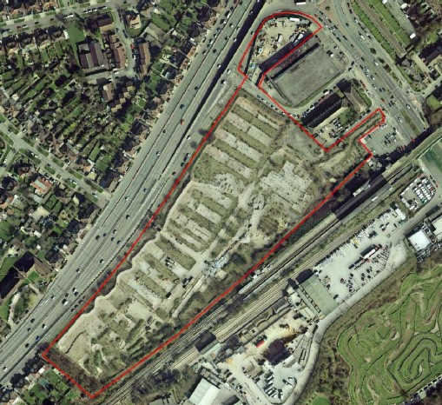

Above, an image of the completed Phase 1

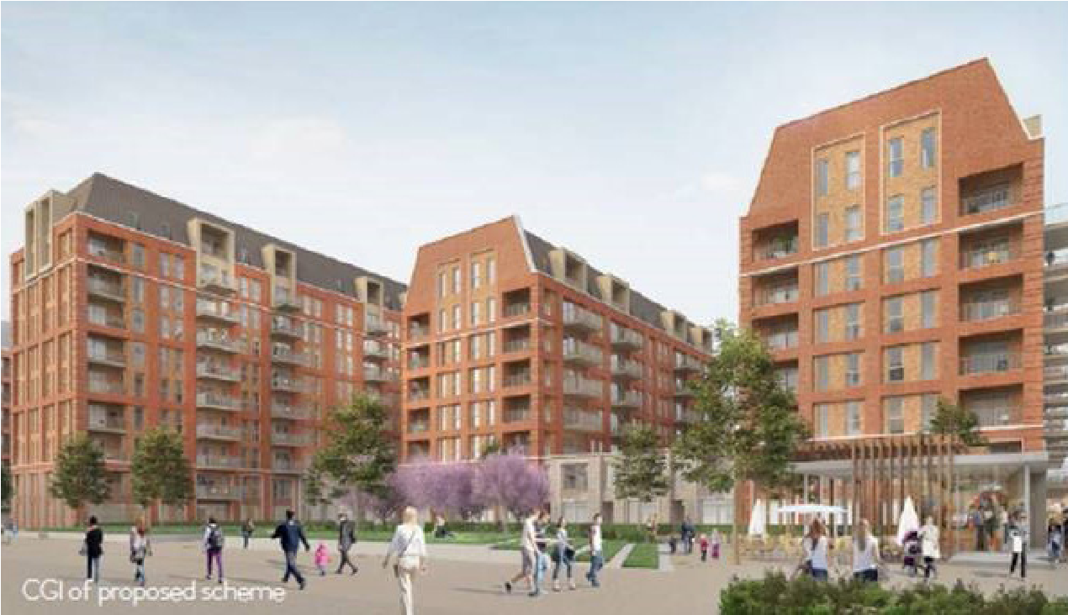

development

# King George’s Gate Construction notice

**Construction update meetings**

Metro Deconstruction Services have been appointed by

The Guinness Partnership to clear King George’s Gate, to prepare for the construction of new homes later this year. They are members of the Considerate Constructors scheme and will endeavour to complete the works with as little inconvenience to neighbours and local businesses as possible.



Construction work will begin onsite on June 22 and will last until

October 2020. There will be noise omitted from the site, but Metro will manage the noise ommissions so that noise levels at the boundary of the site will not exceed industry standards.

Your Shout will be hosting regular meetings throughout the construction process to give the local community an opportunity to ask questions, and give feedback to our project team. Under the Covid-19 measures, these meetings will take place virtually. Once these restrictions are lifted they hope to host in-person meetings with the construction team. Your Shout will write to you well ahead of time, to ensure that you have sufficient notice of these meetings.

Your Shout will also update the guinnesstolworth.org website on a regular basis, with up-to-date site pictures, notice of the next construction meetings as well as views of how the development will look once completed.

## Get in touch Site operating hours

via Freephone: 0800 955 1042 Normal site working hours will be:

via email: tolworth@yourshout.org 8:00am-4.30pm Monday - Friday

8:00am-1:00pm Saturday (occasionally

For regular updates about what’s required)

happening on site, please visit our website No works will be carried out on Sundays **guinnesstolworth.org** or Public Holidays without prior arrangement.

Data will be held by Your Shout and the project team. Your comments, name and address may be given to the council. By volunteering this information, you are giving your consent for us to process your data regarding this project. You are also confirming you are aged 16 or over. You can withdraw your consent for us to use your data at any time by emailing us at privacy@yourshout.com. You have a right to complain to the Information Commissioner’s Office at any time if you feel there is a problem with the way we are handling your data.

