CHESSINGTON DISTRICT RESIDENTS’ ASSOCIATION
Newsletter – May 2020
New Police Constable for Chessington South - Her name is Rachael Cumberbatch. E-mail: Rachael.Cumberbatch@met.pnn.police.uk Welcome to Chessington PC Cumberbatch.
Facebook Scam – Our Chairman reported:-
Last night (Apr 26th) my wife received a Messenger text apparently from a friend of hers.
It started by asking her if she would do her friend a favour.
She replied and said yes.
This was followed by her ‘friend’ saying she had some bills to pay, due the following morning, but her online banking was down.
If she was sent the details, would she pay it for her friend.
It was for £390 and she would be paid back the following morning plus an extra £20. ‘You have my word’.
My wife new immediately that is was not right as it was so out of character for her friend.
She phoned her and it was confirmed her Facebook account had been hacked.
The same message had been sent to a number of people on her contact list.

She contacted Facebook to advise and also changed her password. People on Facebook may be aware of this, but please pass this on.

Royal Mail stopping Saturday Deliveries - Royal Mail has announced that it will stop delivering letters on Saturdays until further notice, amid the COVID-19 pandemic.
Starting on Saturday, May 2, the postal company will "temporarily" no longer deliver letters on a Saturday, but it will continue to deliver Special Delivery, Tracked, all non-account services and "most other parcels" as six days a week, as usual. Royal Mail workers will also continue to collect mail from businesses, post office branches and post boxes as usual.

Car Park at British Legion in Church Lane – Our readers will remember that in September 2019 ‘The Chairwoman of the Eight O’clock Ladies Circle contacted us as to say that the British Legion car park has large pot holes and the street lights did not work. This was very dangerous for the, mainly elderly, ladies that attended evening meetings there. We passed this problem on to Councillor Andreas Kirsch. We are pleased to announce that the pot holes have finally been filled in. However, the lights still do not work. We hope that by the time the dark evenings return they will be fixed.

Council Meetings during the Pandemic - Email from Councillor Lorraine Dunstone. ‘I wanted to keep you updated on the situation with regards to Neighbourhood Planning Decisions.
As you are aware ‘Minor’ applications come to Neighbourhood and would normally be held at the Planning Sub Committee. As the technology for Committee Meetings is still going through testing, the applications that would be due to be heard will be taken under the Emergency Decision making procedures which I have linked below for ease of reference.

https://moderngov.kingston.gov.uk/mgIssueHistoryHome.aspx?IId=44548&Opt=0

All South of the Borough Councillors have been sent the Report packs to review and make their comments to be returned by 1st May.

I wanted to make you aware of the 2 applications coming forward which are 18 Gilders Road which was deferred at the last meeting and 63 Verona Drive in case you wanted to put in representations.

Ultimately the decision will not be made on this occasion by the Councillors but our comments will be taken into account.

We are extremely hopeful that this will be the only occasion that the Emergency procedures would be used where the decision is made by the Assistant Director for Planning and not the Councillors.

With regards to Development Control Committee, the meeting which would of been held on the 29th April has been cancelled and we don’t expect to have to use these Procedures as we anticipate the technology to be up and running for the next rearranged date which has yet to be confirmed’.

Our residents association are very unhappy with the Council’s intention as we consider it to be wholly undemocratic. The two SOTB planning applications that will be decided by the planning department instead of the Councillors are very important, we have made representations on both. The Verona Drive one in particular will change the lives of the existing residents who live there. One of our members has written the following email to the new Leader of the Council, Caroline Kerr.

Dear Councillor Kerr,
‘I am advised that it is your intention under Covid emergency regulations to suspend Councillor consideration of planning applications and hence any public access to Councillors considerations. This is being done solely to meet planning timetables. However, the regulations allow considerable discretion to the Council leader to decide what is so urgent as to override the democratic process of review. The reasoning behind your decision is, I understand, that the Council has been unable to provide a secure and reliable 'virtual meeting' system which would allow Councillors to review applications and the Council may incur financial penalties if planning decisions are delayed. I do not think that poor performance of the Council's I.T. function should be used as an excuse to push through planning decisions.
I believe that would be a disproportionate action as it can be seen that the crisis is approaching, if not past, it's peak and the Government is planning steps to introduce a degree of normality into our lives. I cannot see how such an important decision in the lives of the residents of Verona Drive could be placed in the hands of someone whose department has been worked with the developer and, if the developer's agent is to be believed, has not raised objections to the plans. This is asking the schoolboy to mark his own homework !
If indeed you plan to override democratic oversight in this way, I would ask you to reconsider your decision urgently – it does not reflect professed Lib Dem values of open government reflecting local involvement.’
We have not received a reply from Councillor Kerr. This is disappointing as this is an extremely important issue. As Councillor Kerr is the newly elected leader (by the Liberal Councillors) of the Council we would at least have expected a reply.
Planning News
Tolworth Tower, Second Stage - In October 2019 Meadow Partners received planning permission from Kingston Council for the 261-flat Tolworth Tower build-to-rent scheme.
We have now been advised that there is a webinar being held by Meadow Partners, regarding the proposed second stage of Tolworth Tower .Click here for details https://tolworthtowerphase2.co.uk/
Our Residents Association asked the communications agency responsible for the webinar who they will be consulting. Below is there reply:-
‘We will be showcasing our early principles for phase 2 during the webinar and residents will be able to ask live questions to the project team. As such, no new material will be issued until after the webinar takes place.

The core focus of the consultation will be around the public realm and what the community would like to see delivered. There will be polling questions which attendees can answer during the session to help with this.

We have invited 3113 addresses neighbouring the site to the webinar’.

19/02966 - 11 – 25, Leatherhead Road - Demolition of eight existing residential dwellings and the erection of 43 residential units with associated car and cycle parking, landscaping and access works -
Most of our residents will know of this totally unacceptable planning application. Many of you will have already objected. If you have not done so there is still time as you can continue submitting your comments until the decision has been determined. Email your objection to development.management@kingston.gov.uk. You can read the CDRA objection by clicking on the below link-
http://www.chessingtondra.org.uk/planning-application-19-02966-11-25-leatherhead-road/
The final decision should be made at a Development Control Committee (DCC) and be determined by the Councillors who sit on that committee. The residents will have 5 minutes between them to voice their objections. If there are many people wanting to object this will not work. Therefore, the plan is for interested parties to formulate their objection and for one person to speak. We are hoping for many residents to attend to support the objectors.
However, at the moment we do not know when the DCC meeting will be held. Even worse than that there is a possibility that due to the coronavirus pandemic it will be held as a ‘virtual meeting’ online. Like the planning applications above we think this will be totally undemocratic. It is such a major planning application which is completely wrong for the site. It will affect the lives of many residents if it is allowed to be built. We think it is really important that the residents are allowed to attend the DCC meeting.
One of the key residents who have been working on this application wrote to our MP, Sir Edward Davey to ask for his support. They were due to have a face to face meeting with him but due to the pandemic this was not possible, instead it a telephone discussion took place. We are very pleased to hear that Sir Ed Davey totally agrees with us and thinks the application is wrong for various reasons that you can read about. He has written to the planning department to request that they wait to hold the DCC meeting until the council offices open again. He has also said that he would like to speak at that meeting. We believe that his support could be invaluable to us. You can read the email correspondence together with the email that Ed Davey has sent to the planning department by clicking on the below link.
http://www.chessingtondra.org.uk/planning-application-19-02966-11-25-leatherhead-road/

19/03236/FUL - 18 Gilders Road Chessington KT9 2AL - Erection of 5 self-contained flats (2 x 3 bedroom flats and 3 x 2 bedroom flats) and 1 x single storey 2 bedroom bungalow. This is one of the planning applications that will be decided by the planning department instead of the Councillors. We strongly object to this planning application and the way that it will be decided. Click below to read our objection:- http://www.chessingtondra.org.uk/19-03236-ful-18-gilders-road-chessington-kt9-2al/

20/00505/FUL - Land At 63 Verona Drive Tolworth KT6 5AJ - Demolition of existing garages and erection of 8x semi-detached dwelling houses and associated parking and landscaping. This is the other planning application that will be decided by the planning department instead of the Councillors. We strongly object to this planning application and the way that it will be decided. Click below to read our objection:- http://www.chessingtondra.org.uk/20-00505-ful-land-at-63-verona-drive-tolworth-kt6-5aj/

20/00609 - No 29 The Causeway, Chessington KT9 1DB - Conversion of existing dwellinghouse into 4 self-contained flats (3 x one-bedroom and 1 x two-bedroom) with associated cycle and refuse stores. You can read the CDRA comments on by clicking on the below link:- http://www.chessingtondra.org.uk/20-00609-no-29-the-causeway-chessington-kt9-1db/

20/00588 - 71 Hemsby Road Chessington KT9 2DY - Subdivision of plot and erection of an end of terrace two storey 3x bedroom dwelling. You can read the CDRA comments on our website. Click here:- http://www.chessingtondra.org.uk/20-00588-71-hemsby-road-chessington-kt9-2dy/

20/00692/FUL - 142 Leatherhead Road Chessington KT9 2HU - Demolition of part existing dwelling and erection of 2.5 storey building to provide 3 no. self-contained residential units/flats (2 x two-bedroom and 1 x three bedroom) with associated amenity space, parking for 3 cars, and storage for waste/recycling and cycles. You can read the CDRA comments on our website. Click here:- http://www.chessingtondra.org.uk/20-00692-ful-142-leatherhead-road-chessington-kt9-2hu/

19/00072/FUL - 48 Angus Close Chessington KT9 2BP-Erection of a two storey self-contained 2 bedroom dwelling to the side of 48 Angus Close, KT9 2BP
In February 2020 our Residents Association reported on the proposal to build a small ‘two story self-contained two-bedroom dwelling house’ in the garden of number 48 Angus Close. This was another example of a proposal to build a small house in the garden space at the end of a terrace of houses, in this instance a terrace of semi-detached houses. In recent years we have seen a number of these planning applications. The procedure is that a house owner realises that because the value of houses has greatly increased it has become possible to sacrifice their side garden, no matter how small, to cram in another house. The new house is built and quickly sold. After deducting building cost’s, the owner of the original house makes a very large profit.
The new houses rarely fit comfortably into the existing street scape. The Angus Close development, which was built in 1960, was very well designed. There is a mix of single houses, semi-detached houses and terrace houses. It is very well laid out with a sensible housing density and includes areas of green space. It is popular with home owners and has a low turnover of residents. The ambience of the area is easily destroyed by irresponsible over development.
Our Residents Association and affected residents made a comprehensive response to the planning application, detailing the many reasons that we thought were bad. Perhaps the most horrible proposal was to build a very tall blank side wall that would tower over the small gardens and homes of the six adjacent houses, numbers 36 to46.
These are a terrace of small houses which are at right angle to number 48 and lay alongside its garden perimeter. This part of Angus Close is built on a hillside. The front gardens of 36 to 48 rise about two metres to the access footpath leading to all of the houses. Alongside the length of the foot path, on the number 48 side, is a metre-high retaining wall which determines the level height of the land upon which number 48 is built. This creates a peaceful, quiet, car free series of gardens which are well maintained by their owners. A little paradise!
The proposed new build would have a huge blank wall on top of the retaining wall that will be at least 8 metres, that is 25 feet high. It would be full height for the depth of the main part of new house and half height for the kitchen extension. This monstrosity would be only 10.4 meters, 34 ft, in front of the Angus Close houses! The planning proposal admits that it will blot out twenty percent of the available sunlight. If the residents of the houses at numbers 36 – 46 stood at the front window of their living-rooms they would be confronted by a huge blank brick wall. They would have to risk a crick in their necks if they wanted to see the sky. Please note their view would comprise the 2metre rise in their own gardens, the metre high retaining wall of number 48, then the 8 metre plus height of the brick wall. Eleven metres or about 35 ft minimum! The photograph below is of a similar wall on a house further down Angus Close. The difference between the two walls is that the wall of the new planning application will be significantly higher than that of house in the photograph. The wall in the photograph is alongside the garage blocks and does not affect any other properties.

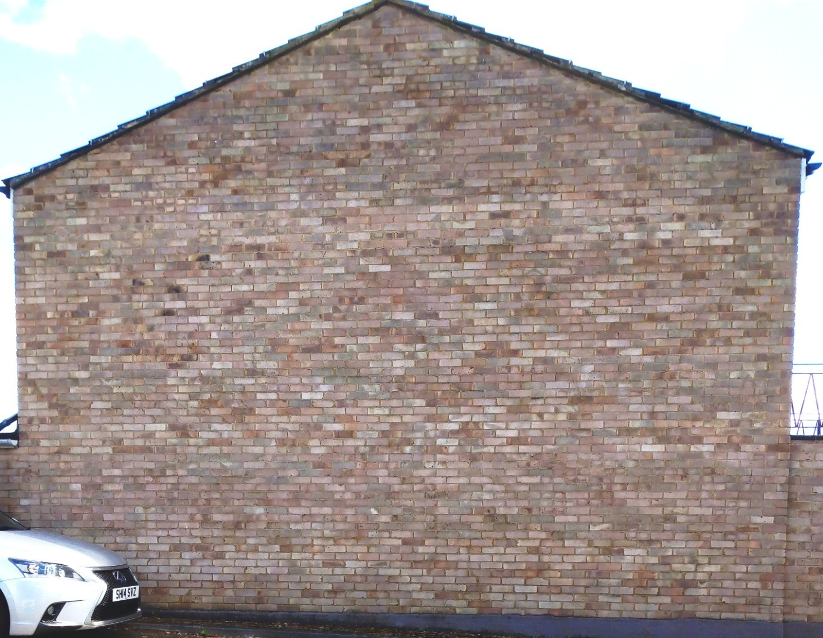
The Residents Association think that the proposed building will be very bad for the established residents. It is a settled community. There are twelve people living in the six affected houses. Nine have lived there for twenty years or more, the most recent arrivals were eight years ago. There are four or five old aged pensioners, three or four young, or not so young middle-aged people and four people, including a child, under the age of 30. Surely, such residents should be allowed to live their lives in their chosen homes without the risk of an opportunistic developer spoiling their environment, the quality of their homes and their quality of life!
We were amazed when the Councillors gave planning permission at the Neighbourhood Committee meeting on the 10th of March. Eight of the local Councillors were present. However, only those five Members who had comprised of the Sub-Committee took part in the deliberations and voting on this application. All five voted to give planning permission!
Such voting unity is suspicious. When Councillors have free votes there are always a few with independent minds who will vote objectively on the specific issues. In this case there were many that were particularly bad. The unity of the seven who voted had all the hallmarks of a political decision.
We discussed this with a retired member of our Residents Association Committee. His comment was that he was surprised at the votes, saying that in the past we had always thought the Liberal Councillors could be expected to look after their resident’s interests. In recent years we have had an excellent working relationship with Sir Edward Davey when dealing with local problems. We cannot understand how local Councillors could so blatantly turn against the interests of the local residents!
It may relate to the pressure that the Council is under from the Mayor of London to build new homes. Yet this application was for only one house of dubious size and quality. Even the Councils planning officer said that it barely conforms to the Councils minimum internal gross floor size. That is 79 square metres. This one squeaks in at 83 square metres. Our Residents Association thinks that we should not allow inferior houses’ that spoil the local built environment, and damage adjacent resident’s quality of life, to be built!.

